**Jeffrey Walley**

# **Soft Skills vs. Hard Skills**

Everyone has different personal qualities. That is what makes us unique. Employers want to know that you have certain personal qualities like the ability to get along with others or that you are honest and trust worthy.

Instructions: Read the different scenarios and then determine what skills and personal qualities the person has for the job. You can fill in your personal profile on the last one.

**Joe**

Joe is a builder. He has moved to Yellowknife from a small community and is now looking for a job. He 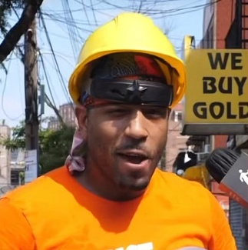sees a job advertised in the *Yellow Knifer* for a Carpenter’s Helper. He wants to apply.

Joe is strong, healthy and good at physical work. He can use a range of different tools and maintain them in good condition. He knows how to dig trenches, erect scaffolding and mix and pour concrete. He can prepare and clean wall surfaces for painters. He is reliable, can follow instructions and work at a good pace. He works well with other people and enjoys working outside.

What skills and personal qualities should Joe put in his resume?

|  |  |
| --- | --- |
| **Hard Skills** | **Soft Skills** |
| Labor and Carpentry Experience | Excellent at Physical Labor |
| Knowledge of Hand and Power Tools | Willing to Work Hard |
| Knowledge of Tool Maintanance | Reliable |
| Experience with Concrete | Can Follow Instructions |
| Can Assemble and Disassemble Scaffolding | Quick Pace of Work |
| Willing to Dig Trenches | Works Well with Others |
| Experience Cleaning and Prepping Surfaces for Paint | Enjoys Working Outside |
|  |  |
|  |  |
|  |  |

**Jane**

Jane worked as an administrative assistant for five years. She then stayed at home to be with her children for a couple of years. She would like to apply for an administrative assistant position at the C&P Associate.

Jane dresses neatly and is always well presented. She is friendly, helpful and courteous to both customers and other employees. She can use a range of computer applications such as word processing, email and the Internet. She can type reports and maintain files. She has good telephone skills and is reliable with messages and other communication. She is very organized and careful with her work.

What skills and personal qualities should Jane put in her resume?

|  |  |
| --- | --- |
| **Hard Skills** | **Soft Skills** |
| Experience as administrative assistant (5 years) | Compasionate Mother |
| Computer knowledge | Well dressed and presented |
| Word Processing | Exceptional telephone skills |
| Can answer and relay email | Great communication skills and message handling |
| Reports (Spreadsheets?) | Extremely organized |
| Experience with Filing and file maintainance | Exacting with her work |
|  |  |
|  |  |
|  |  |
|  |  |

**Mabel**

Mabel worked as a Community Health Representative in her community for many years. She had some training in the health field for this specific job. She has recently moved to Hay River and would like to pursue a career in the health field. She sees an advertisement for a home care aide in News North. She would like to apply.

Mabel has experience promoting health issues and concerns in her community. She is able to translate health concerns for elders at the health center. She is good at keeping records and files organized. She has very good computer skills. She can make posters and type reports. Mabel is very caring, friendly, and good with people. She enjoys helping others and is very sensitive to people’s needs. She is hard working and always on time.

What skills and personal qualities should Mabel put in her resume?

|  |  |
| --- | --- |
| **Hard Skills** | **Soft Skills** |
| Training as Communit Health Rep | Enjoys helping others |
| Experience as Community Health Representative (years) | Can help elderly patients to better understand and communicate their health concern |
| Experience as a community advocate promoting health issues and concerns in Hay River | Organized |
| Has a knowledge of health concerns for elders | Keeps great records |
| Computer Skills | Caring and friendly |
| Poster Design | Sensitive to others needs (empathetic) |
| Typing Reports | Driven worker |
|  | Punctiual |
|  |  |
|  |  |

**Sam**

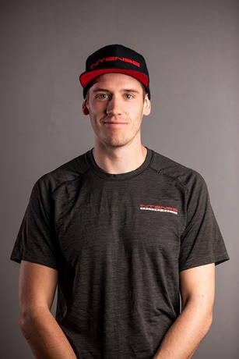Sam is a small engine mechanic. He has always worked for himself repairing snow machines, boats and other small engines. He is tired of dealing with his own business and now wants to work for someone else. He sees an advertisement in the paper for a small engine repair mechanic and decides to apply.

Sam has been working on boats and snow machines ever since he can remember. He has taken a few courses here and there on small engine repair but for the most part he knows more about small engine repair than the instructors. He is very knowledgeable about engines and can just listen to the engine and know what is wrong. Sam is a very likeable person; he is friendly to everyone and knows how to work well with others. Sam works hard and always gets the job done. What skills and personal qualities should Sam put in his resume?

|  |  |
| --- | --- |
| **Hard Skills** | **Soft Skills** |
| Experience as small engine mechanic | Intuitive knowledge of small engines and motors |
| Extensive knowledge of snow machines, boat motors, and other small engines | Self driven worker that completes tasks |
| Years of experience and a strong knowledge of engines, how they run, and how to fix and maintain them | Friendly and likable to coworkers and customers |
| Years of business ownership | Hard worker |
| Extensive customer assistance experience | Works well with others |
| Some training |  |
|  |  |
|  |  |
|  |  |
|  |  |